**1.QUADRATIC ROOTS :**

import java.util. *;

//import java.lang.Math;

public class Main

{

public static void main(String[] args) {

System.out.println("Enter the values for Co-efficiants a,b and c for the expression ax^2+bx+c :");

Scanner input = new Scanner(System.in);

int a = input.nextInt();

int b = input.nextInt();

int c = input.nextInt();

double r1,r2;

double d = (b*b)-4*a*c;

if(a==0&&b==0&&c==0){

System.out.println("Invalid Input Please enter valid Data");

}

if(d<0){

System.out.println("There are no Real Roots existing");

}

else if(d==0){

r1= (-b)/(2*a);

System.out.println("The roots are equal and the value is equal = "+r1);

}

else if(d>0){

r1= (-b+Math.sqrt(d))/(2*a);

r2= (-b-Math.sqrt(d))/(2*a);

System.out.println("This has got two Real and distcint roots and the values are ="+r1+" and "+r2);

}

}

}

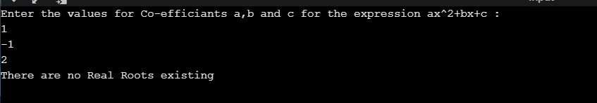

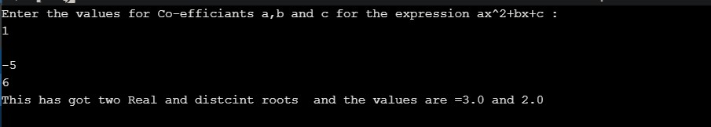

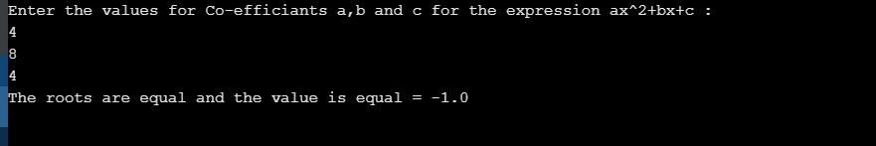

**2. Create a student class , and calculate his/her grade, depending upon CIE and SEE marks :**

import java.util.Scanner;

class student{

String usn;

String name;

float[] credits= new float[30];

float[] marks = new float[30];

float[] grade = new float[30];

Scanner in = new Scanner(System.in);

void input(int n) {

for(int i=0;i<n;i++) {

System.out.println("Enter credit of subject"+(i+1));

credits[i]=in.nextFloat();

System.out.println("Enter marks of subject"+(i+1));

marks[i]=in.nextFloat();

if(marks[i]>=90&&marks[i]<=100){grade[i]=10;}

else if(marks[i]>=80&&marks[i]<=90){grade[i]=9;}

else if(marks[i]>=70&&marks[i]<=80){grade[i]=8;}

else if(marks[i]>=60&&marks[i]<=70){grade[i]=7;}

else if(marks[i]>=50&&marks[i]<=60){grade[i]=6;}

else if(marks[i]>=40&&marks[i]<=50){grade[i]=5;}

else if(marks[i]>=0&&marks[i]<=40){grade[i]=0;}

}

}

void output(float credits[],float grade[],int n) {

float sum=0,cre=0,sgpa;

for(int i=0;i<n;i++)

{ sum = sum + (credits[i]*grade[i]);

cre=cre + credits[i];

}

sgpa = sum/cre;

System.out.println("Student Details are :");

System.out.println("Name : " +name);

System.out.println("USN : " +usn);

System.out.println("SGPA : " +sgpa);

}

}

class Main{

public static void main(String args[])

{

student s= new student();

int n;

Scanner input = new Scanner(System.in);

System.out.println("Enter name of Student");

s.name=input.nextLine();

System.out.println("Enter USN");

s.usn = input.nextLine();

System.out.println("Enter number of subjects");

n = input.nextInt();

s.input(n);

s.output(s.credits, s.grade, n);

}

}

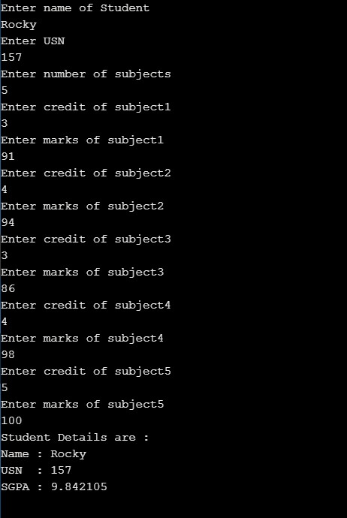

**3 . Create BOOK class , with author name , price, no.of pages , book name ,Create methods to perform basic operations and use toString function .**

import java.util.*;

class Book{

String B_name = new String();

String B_AuthName = new String();

int price;

int num_pages;

Scanner classINP = new Scanner(System.in);

void input (){

System.out.println("Enter Name");

B_name = classINP.nextLine();

System.out.println("Enter Author Name");

B_AuthName = classINP.nextLine();

System.out.println("Enter price");

price = classINP.nextInt();

System.out.println("Enter No of Pages");

num_pages = classINP.nextInt();

}

public String toString(){

return("Book name = "+B_name+" \nAuthor = "+B_AuthName+ "\nPrice = "+price+"\nPages = "+num_pages);

}

}

class main{

public static void main(String[] args) {

Scanner mainInp = new Scanner(System.in);

System.out.println("Enter the no.of BOOKS details you wanna enter");

int n=mainInp.nextInt();

Book BOOKS[] = new Book[n];

for (int i = 0; i < BOOKS.length; i++) {

System.out.println("Enter the details of BOOK "+ (1+i));

BOOKS[i]=new Book();

BOOKS[i].input();

}

for (int i = 0; i < BOOKS.length; i++) {

System.out.println("The Details of BOOK "+ (1+i) +"are being Displayed");

System.out.println(BOOKS[i]+"\n\n");

}

}

}

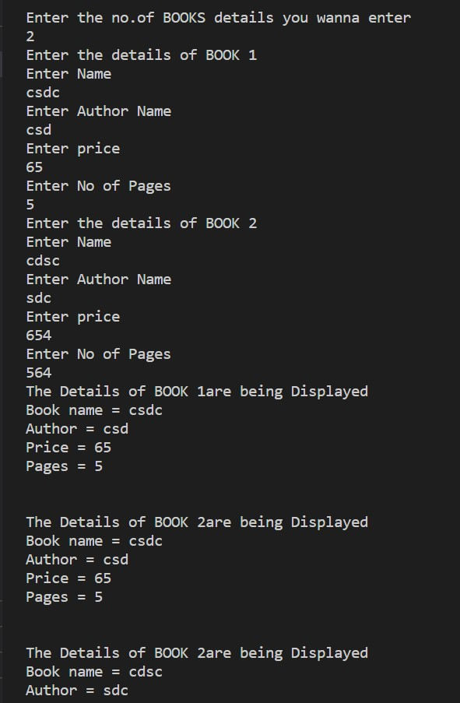

**4 . Create Area class , use INHERITANCE concept , create a abstract function printArea.**

import java.util.*;

class Shape{

int S_lenght;

int S_breadth;

void printArea(){

}

Scanner S_inp = new Scanner(System.in);

}

class Rectangle extends Shape{

void printArea(){

System.out.println("Enter the lenght of Rectangle");

S_lenght = S_inp.nextInt();

System.out.println("Enter the breadth of Rectangle");

S_breadth = S_inp.nextInt();

System.out.println("The AREA of RECTANGLE is : "+ (S_breadth*S_lenght));

}

}

class Trinagle extends Shape{

void printArea(){

System.out.println("Enter the Height : ");

S_lenght = S_inp.nextInt();

System.out.println("Enter the Base : ");

S_breadth = S_inp.nextInt();

System.out.println("The AREA of TRIANGLE is : " +(.5*S_breadth*S_lenght));

}

}

class Circle extends Shape{

void printArea(){

System.out.println("Enter the Radius :");

S_lenght = S_inp.nextInt();

System.out.println("The AREA of CIRCLE is : "+(3.143*S_lenght*S_lenght));

}

}

public class App {

public static void main(String[] args) throws Exception {

Rectangle R1 = new Rectangle();

Trinagle T1 = new Trinagle();

Circle C1 = new Circle();

R1.printArea();

T1.printArea();

C1.printArea();

}

}

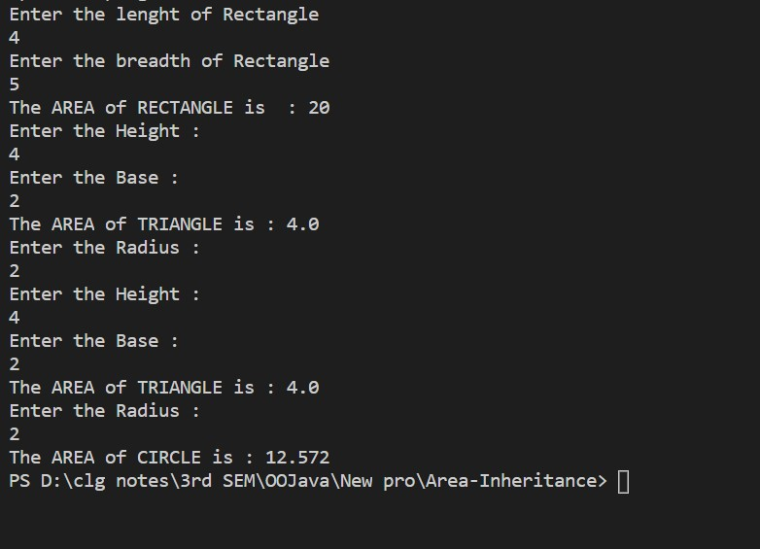

**5 . create a BANK class , Create two subclasses savings and current , create necessary method inside each class .**

import java.util.*;

//Bank class

class Bank{

Bank(){

System.out.println("BANK");

}

Scanner B_inp = new Scanner(System.in);

}

//Account class

class Account extends Bank{

int A_no;

String A_Name = new String();

int A_accType;

void getAccData(){

System.out.println("Enter the Account Name : ");

A_Name = B_inp.nextLine();

System.out.println("Enter the Account Type : (1.for Savings account 2.Current account)");

A_accType = B_inp.nextInt();

System.out.println("Enter The Account number :");

A_no = B_inp.nextInt();

}

}

//SaveAcc class

class SaveAcc extends Account{

double Bal;

int Intrest = 3;

void getDeposite(int Depo, SaveAcc ob) {

ob.Bal = ob.Bal+Depo;

System.out.println("The Balance amount after deposition is : " +ob.Bal);

}

void getBal(SaveAcc ob) {

if (ob.Bal >= 5000) {

System.out.println("The balance amount is " + ob.Bal);

} else if (ob.Bal<5000 && ob.Bal!=0) {

ob.Bal = ob.Bal - 10;

System.out.println("You dont have minimum Balance ");

System.out.println("The balance amount after the charges deduction is " + ob.Bal);

}

else if(ob.Bal==0){

System.out.println("Balnce : 0");

}

}

void getBalintrest(SaveAcc ob){

ob.Bal= ob.Bal+(0.03)*(ob.Bal);

System.out.println("The balance amt after computing the intrest is "+ ob.Bal) ;

}

void getWithdraw(SaveAcc ob,int WithD){

if(WithD<=ob.Bal){

ob.Bal = ob.Bal - WithD;

System.out.println("Your current balance after the withdrawal is " + ob.Bal);

}

else{

System.out.println("Insufficient balance");

}

}

void GetACCinfo(SaveAcc ob, String Name, int No){

System.out.println("Your Account Details are : ");

System.out.println("NAME :" + Name);

System.out.println("AccNO : "+ No);

System.out.println("AccType : Savings Account");

System.out.println("Current balance "+ob.Bal);

}

}

//Curr class

class CurrACC extends Account{

double Bal;

void getDeposite(int Depo,CurrACC ob) {

ob.Bal = ob.Bal + Depo;

System.out.println("The Balance amount after deposition is : " + ob.Bal);

}

void getBal(CurrACC ob) {

if(ob.Bal>=5000){

System.out.println("The balance amount is " + ob.Bal);

}

else if(ob.Bal < 5000 && ob.Bal != 0){

ob.Bal=ob.Bal-10;

System.out.println("You dont have minimum Balance ");

System.out.println("The balance amount after the charges deduction is " + ob.Bal);

}

else if (ob.Bal == 0) {

System.out.println("Balnce : 0");

}

}

void getWithdraw(int WithD,CurrACC ob) {

if (WithD <= ob.Bal) {

ob.Bal = ob.Bal - WithD;

System.out.println("Your current balance after the withdrawal is " + ob.Bal);

} else {

System.out.println("Insufficient balance");

}

}

void GetACCinfo(CurrACC ob , String Name , int No ) {

System.out.println("Your Account Details are : ");

System.out.println("NAME :" + Name);

System.out.println("AccNO : "+ No);

System.out.println("AccType : Current Account");

System.out.println("Current balance " + ob.Bal);

}

}

//Main class

public class App {

public static void main(String[] args) throws Exception {

Scanner M_inp = new Scanner(System.in);

System.out.println("*****Welcome to Bank of KGF Service*****");

System.out.println("Please enter the information below :");

Account A1= new Account();

A1.getAccData();

if(A1.A_accType==1){

SaveAcc S1 = new SaveAcc();

System.out.println("Savings Account created Successfully");

System.out.println("Enter the corresponding option to Proceed further");

for(;;){

System.out.println(

"1.Deposite\n2.Balance\n3.Withdrawal\n4.Balance with intrest\n5.To get your Account INFO\nAny other key to exit");

int c = M_inp.nextInt();

switch (c) {

case 1:

System.out.println("Enter the amount to be Deposited");

int Depo = M_inp.nextInt();

S1.getDeposite(Depo, S1);

break;

case 2: S1.getBal(S1);

break;

case 3:

System.out.println("Enter the amount for Wthdrawal");

int WithD = M_inp.nextInt();

S1.getWithdraw(S1, WithD);

break;

case 4:

S1.getBalintrest(S1);

break;

case 5:

S1.GetACCinfo(S1 , A1.A_Name , A1.A_no);

break;

default:

System.exit(0);

break;

}

}

}

else if(A1.A_accType==2){

CurrACC C1 = new CurrACC();

System.out.println("Current Account created Successfully");

System.out.println("Enter the corresponding option to Proceed further");

for (;;) {

System.out.println("1.Deposite\n2.Balance\n3.Withdrawal\n4.4To get your Account INFO\nAny other key to exit");

int c = M_inp.nextInt();

switch (c) {

case 1:

System.out.println("Enter the amount to be Deposited");

int Depo = M_inp.nextInt();

C1.getDeposite(Depo, C1);

break;

case 2:

C1.getBal(C1);

break;

case 3:

System.out.println("Enter the amount for Wthdrawal");

int WithD = M_inp.nextInt();

C1.getWithdraw(WithD, C1);

break;

case 4:

C1.GetACCinfo(C1, A1.A_Name, A1.A_no);

break;

default:

System.exit(0);

break;

}

}

}

else{

System.out.println("Service Terminated");

}

M_inp.close();

}

}

